
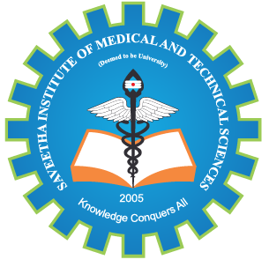
SIMATS ENGINEERING

Saveetha Institute of Medical and Technical Sciences
Chennai- 602105

Student Name: M. GOKUL Reg. No: 192565067
Course Code: CSA5803 Slot: C
Course Name: DEVSECOPS Engineering and Application Security
Course Faculty: Dr. R. Pitchandi
Project Title: CI/CD Pipeline Automation with Integrated SAST, DAST, and SCA
Module Photographs:
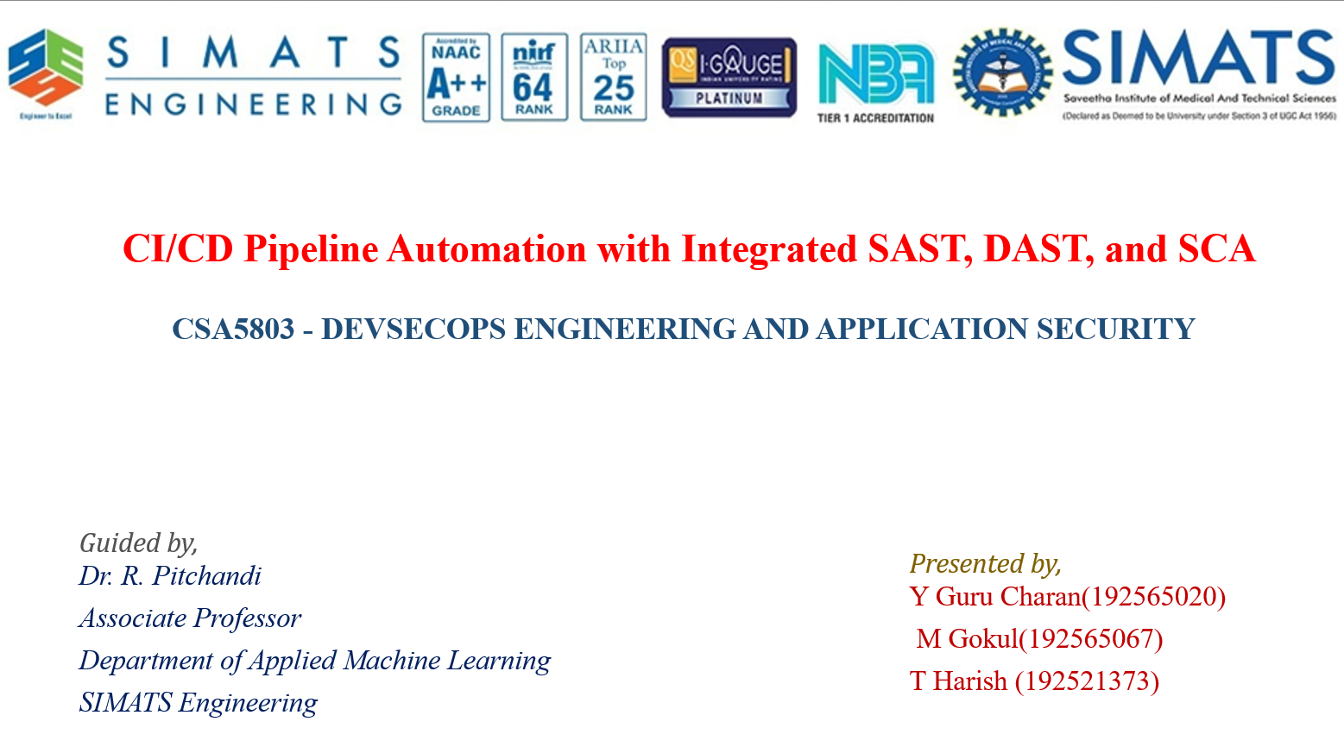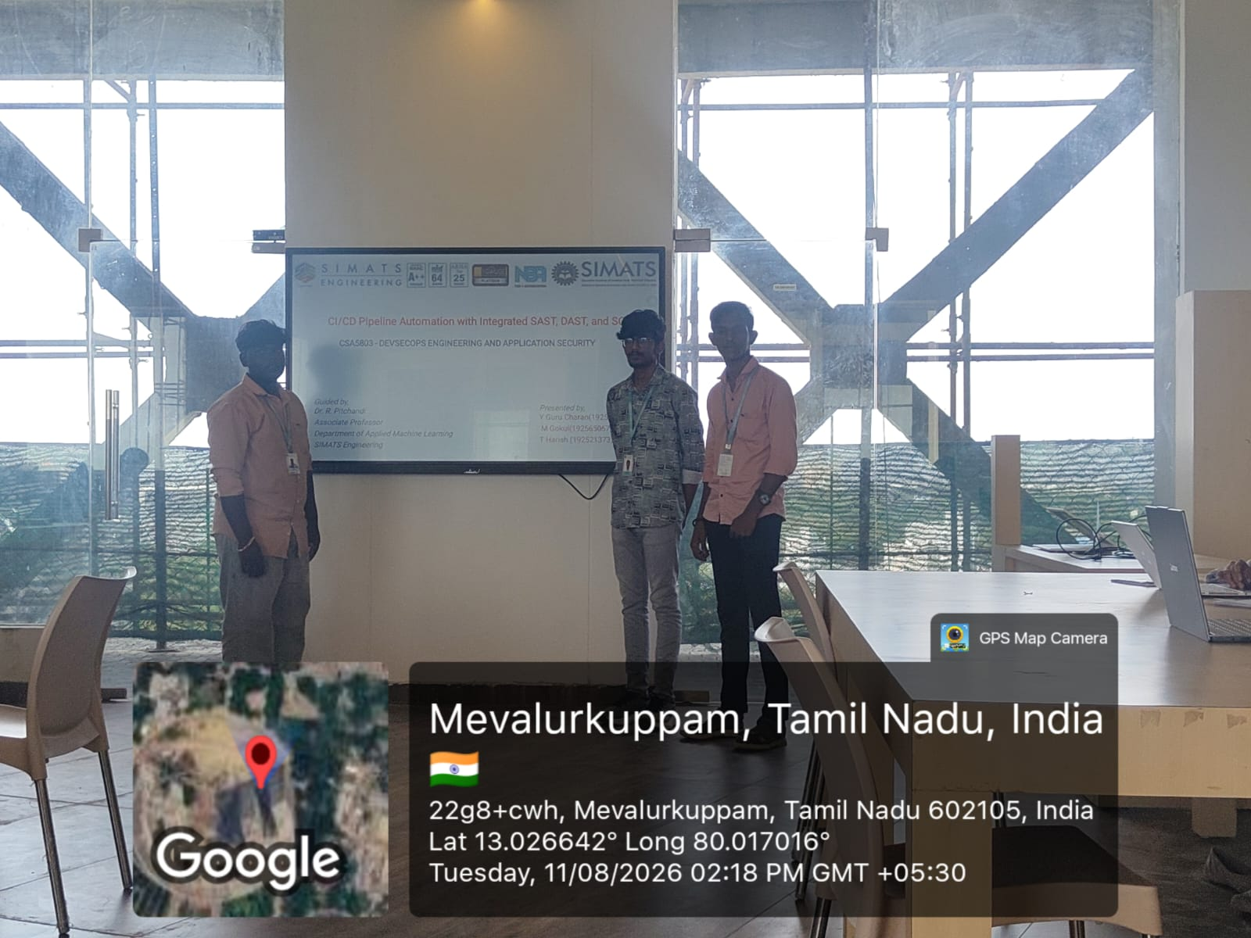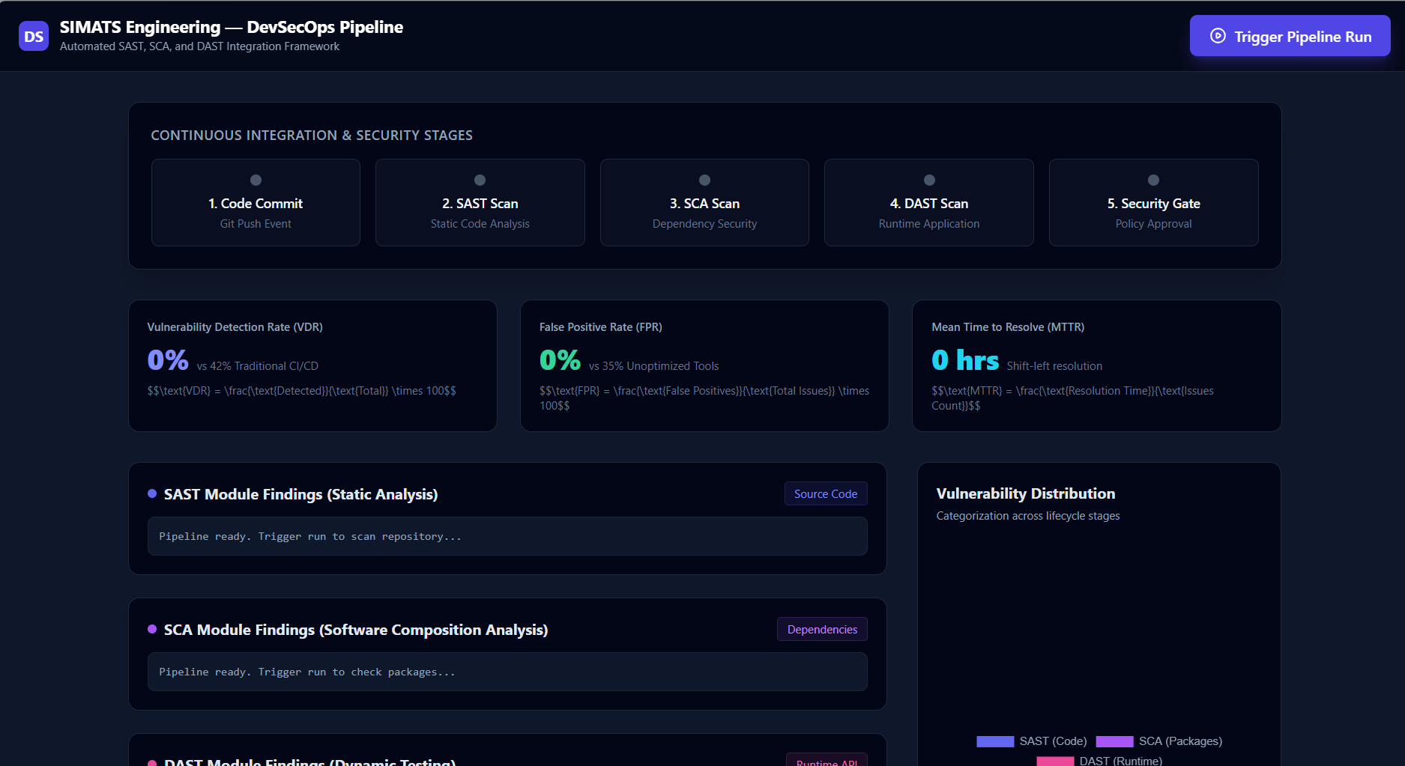

Project Description:
The project “CI/CD Pipeline Automation with Integrated SAST, DAST, and SCA” focuses on implementing an automated DevSecOps pipeline that integrates security practices throughout the software development and delivery lifecycle. The system automates the processes of source code building, testing, security analysis, and application deployment using a Continuous Integration and Continuous Deployment (CI/CD) pipeline. Static Application Security Testing (SAST) analyzes source code to identify vulnerabilities and coding weaknesses before deployment, while Dynamic Application Security Testing (DAST) evaluates the running application to detect security issues during execution. Software Composition Analysis (SCA) scans third-party libraries and dependencies for known vulnerabilities and outdated components. Security checks are incorporated as automated pipeline stages, enabling early detection and remediation of vulnerabilities. The project demonstrates how DevSecOps practices can improve application security, reduce manual intervention, accelerate secure software delivery, and establish a continuous security validation process throughout the development lifecycle.

Student Signature Guide Signature

